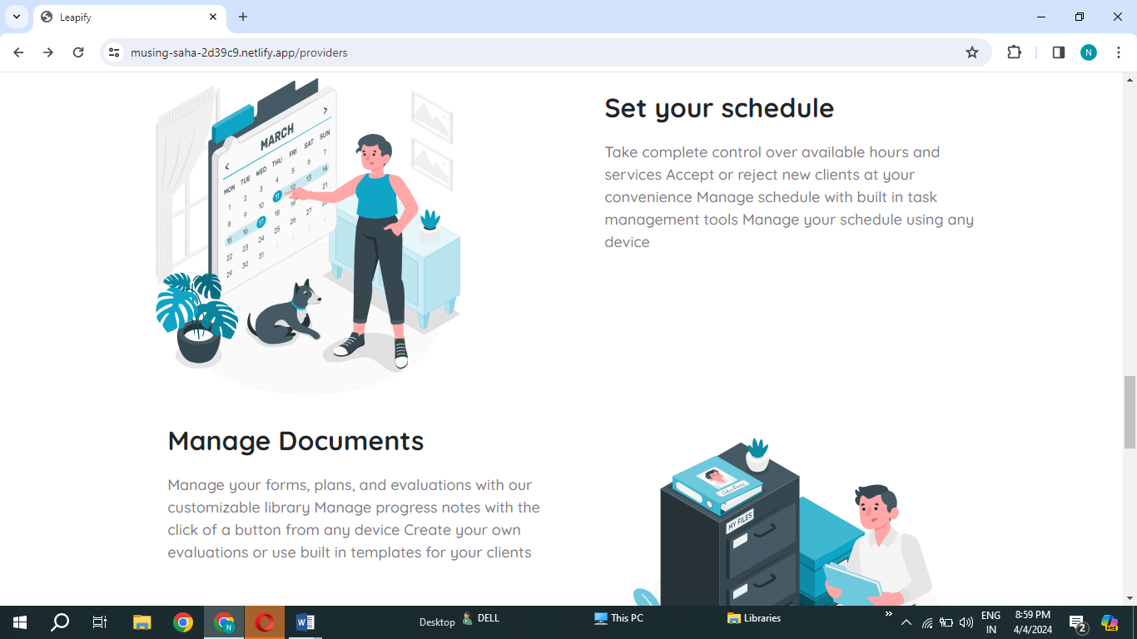

1. Your schedule --- in this your ‘Y’ ans ‘s ’ Should be capital
2. Accept and Manage ---‘A’ and ‘M’ are capital should be small
3. And extra ‘,’ is present
4. Manage and Create---‘C ’ and ‘M’ are capital should be small